NEWS LETTER:

<https://wout6.wordpress.com/2023/09/13/emai-newsletter/>

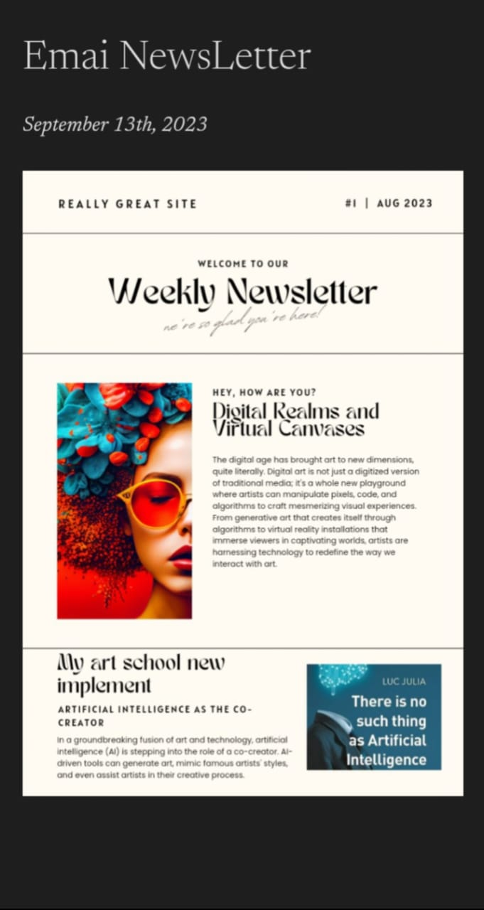

BLOG:

<https://wout6.wordpress.com/2023/09/13/my-art-school/>

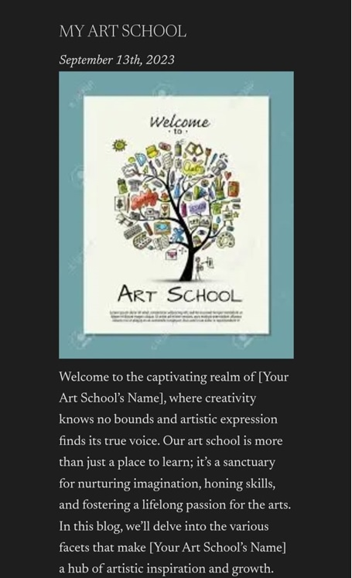

INFOGRAPHI:

<http://wordpress.com/2023/09/13/my-art-creativity-techniques>

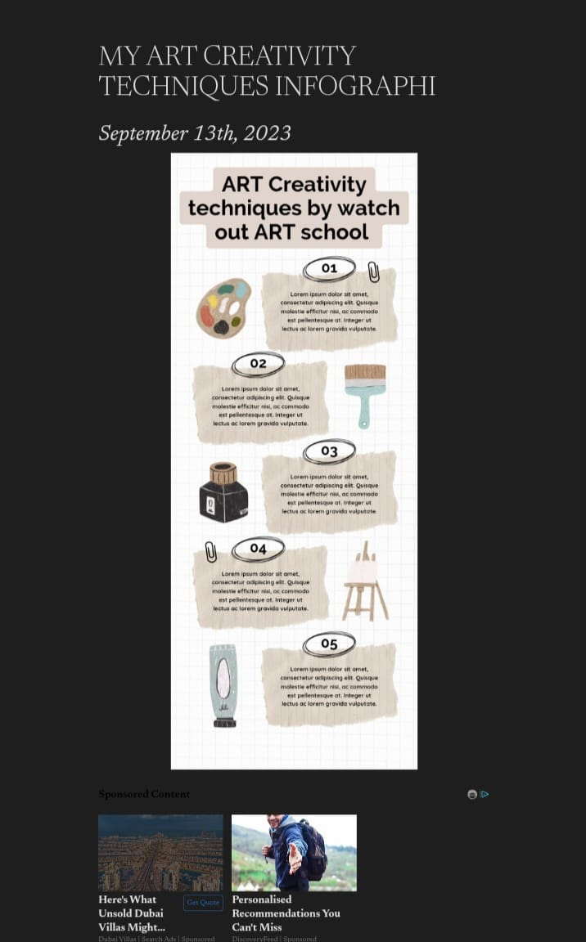

FACEBOOK PAGE:

<https://www.facebook.com/profile.php?id=61550272983146&mibextid=ZbWKwL>

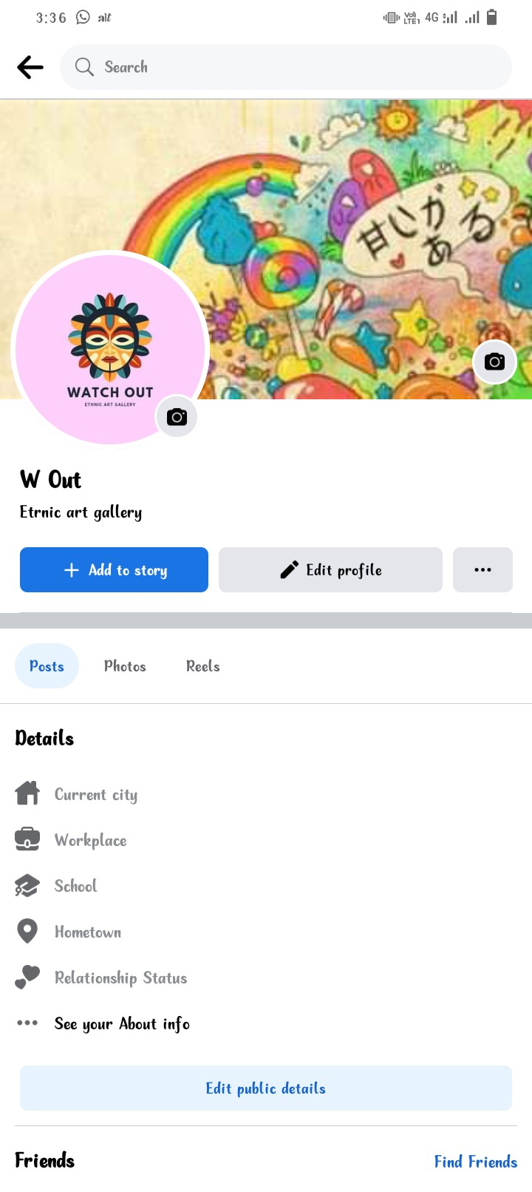

FACEBOOK POST:

<https://www.facebook.com/profile.php?id=61550272983146&mibextid=ZbWKwL>

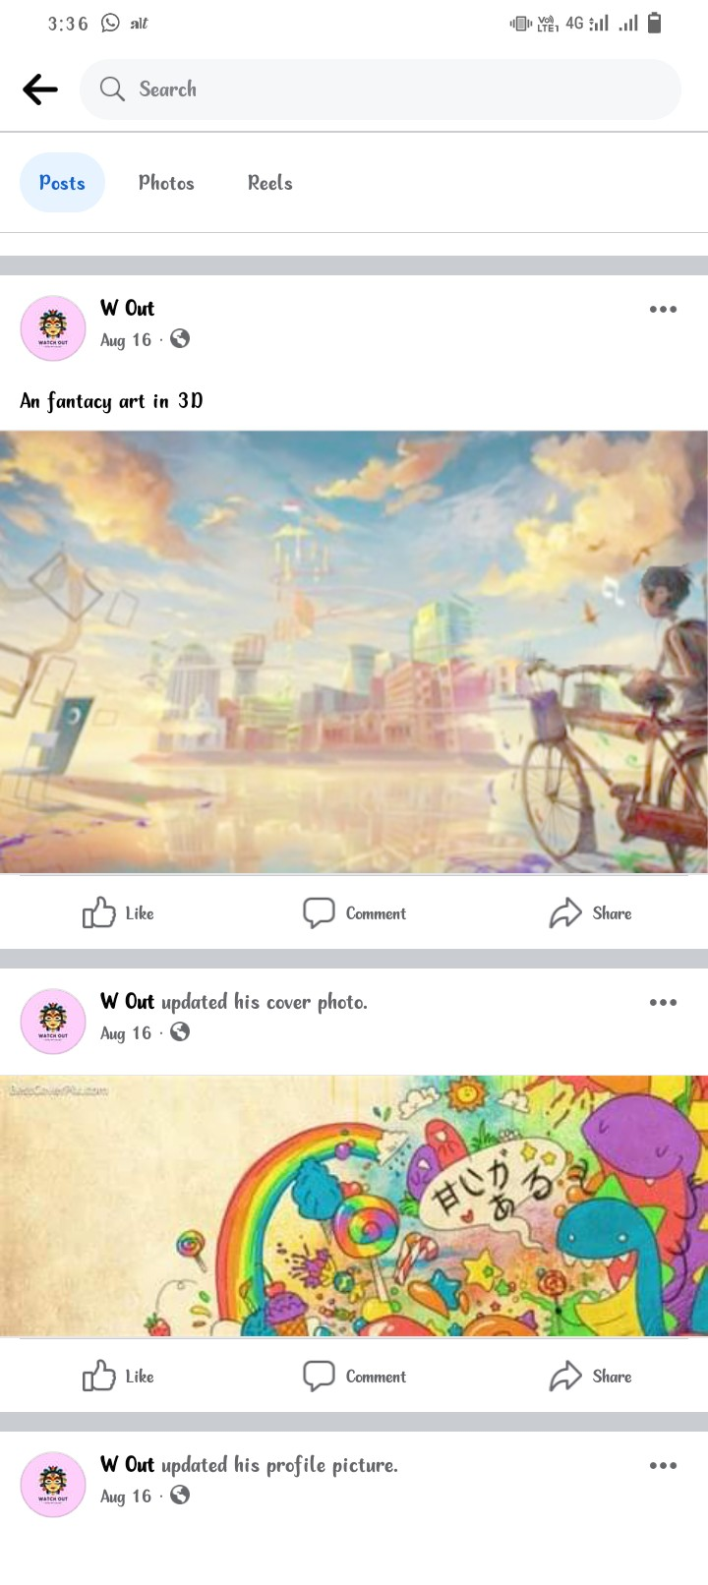

LINKDEN PAGE:

<https://www.linkedin.com/in/tamil-selvan-e-78192a21b?utm_source=share&utm_campaign=share_via&utm_content=profile&utm_medium=android_app>

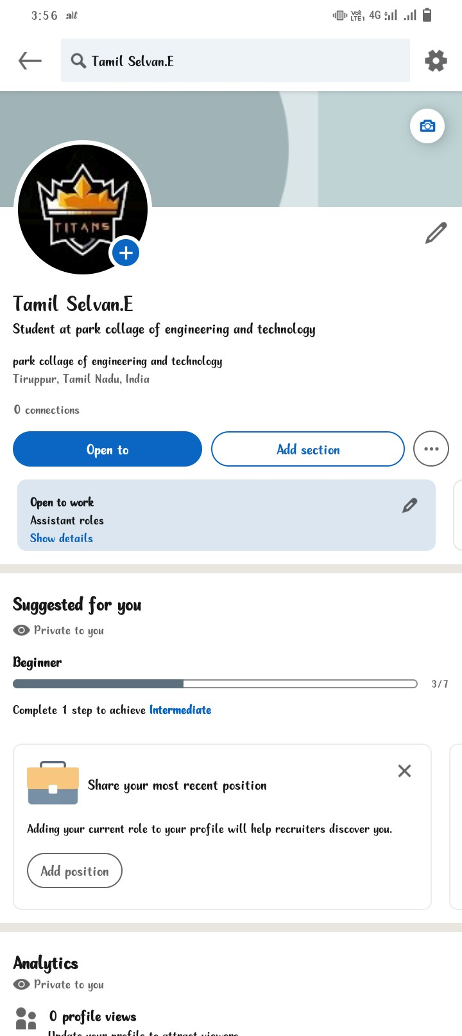

ANALYTICS:

<https://analytics.google.com/analytics/web/?authuser=0#/p406797689/reports/intelligenthome>

